1. Doji: This candle represents many things in the market. It has same opening and closing which means bulls and bears are same powerful.
   1. It represents equilibrium in the market.
   2. It also represents confusion in the market.
2. 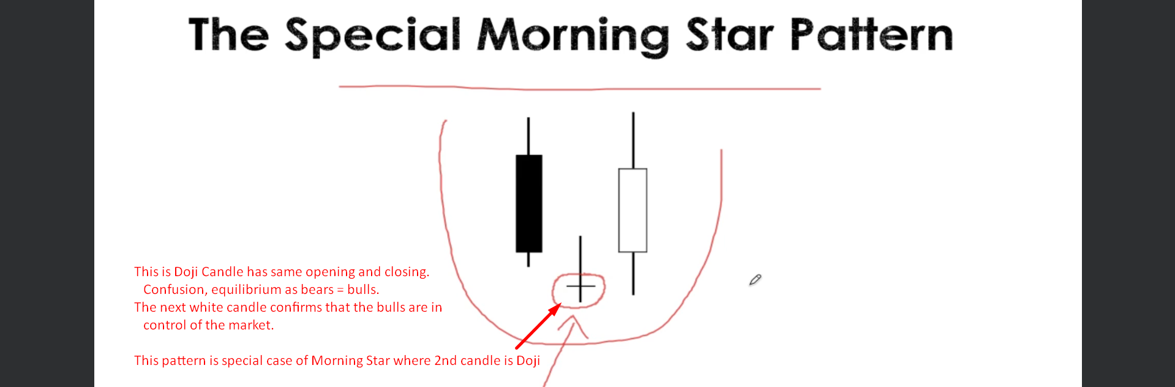
3. 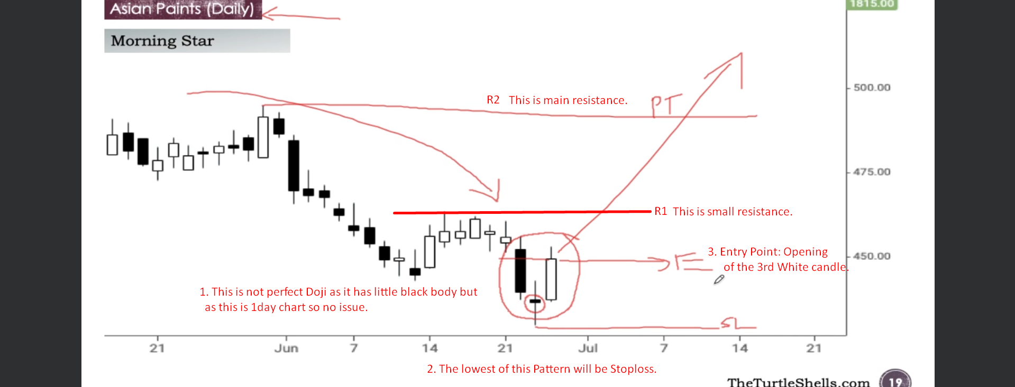
4. 